1. Same as CW1 Q3 (in 2020), answer -> <https://materials.doc.ic.ac.uk/view/2021/70023/Course%20Material/15>
2. Same as CW2 Q1 (in 2020)
3. Same as CW2 Q3 (in 2020)
4. A) Its essentially traversing through alpha and treating beta as a stack, each open bracket in alpha must be eventually followed by a matching close bracket

b) Can combine the two pre-conditions and apply reverse distributivity to get clist() AND (True), then combine the two post-conditions and apply distributivity to get the post of wellBr

c) i) wb(alpha) because you need it again for the post and it gets modified in the loop

ii) (and consing it into a ^ and the end instead of \*) 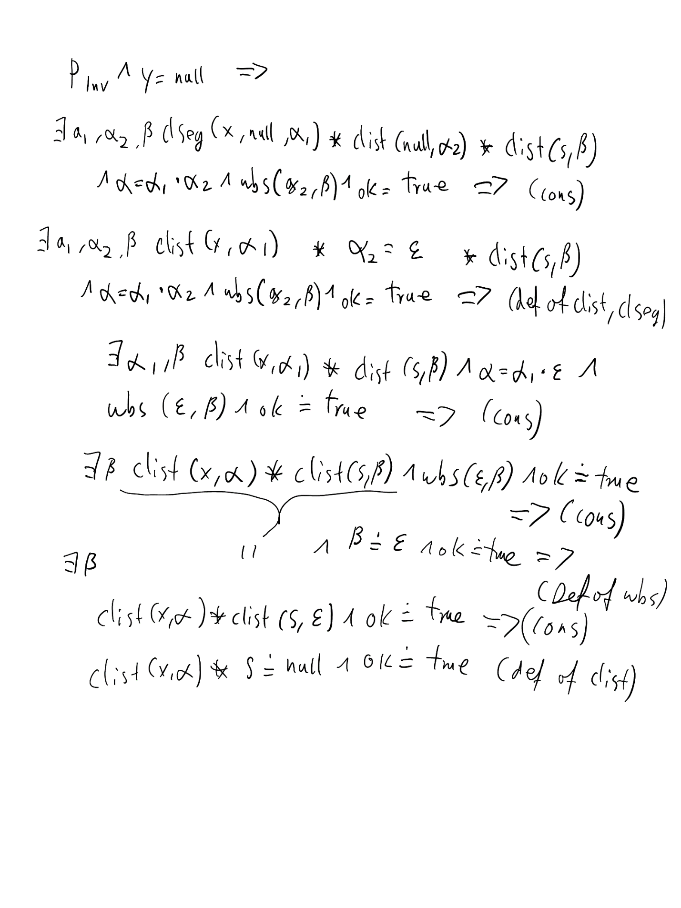

d) 